**Practical 10**

**Data Visualization and Storytelling**

**Create meaningful visualizations using data visualization tools Combine multiple visualizations to tell a compelling data story. Present the findings and insights in a clear and concise manner.**



import numpy as np import pandas as pd

import matplotlib.pyplot as plt import seaborn as sns

# Sample Data np.random.seed(42) df = pd.DataFrame({

'Years of Experience': np.random.randint(1, 20, 100),

'Salary': np.random.randint(30000, 120000, 100),

'Department': np.random.choice(['HR', 'IT', 'Finance', 'Marketing'], 100)

})

# 1 SCATTER PLOT: Experience vs Salary plt.figure(figsize=(8, 5))

sns.scatterplot(x=df['Years of Experience'], y=df['Salary'], hue=df['Department'], palette='viridis')

plt.xlabel("Years of Experience") plt.ylabel("Salary")

plt.title("Experience vs Salary Distribution") plt.legend(title="Department")

plt.show()

# 2 BAR PLOT: Average Salary by Department (FIXED) plt.figure(figsize=(8, 5))

sns.barplot(x=df['Department'], y=df['Salary'], estimator=np.mean, hue=df['Department'], dodge=False)

plt.xlabel("Department") plt.ylabel("Average Salary") plt.title("Average Salary by Department")

plt.legend(title="Department", loc="upper right") plt.show()

# 3 HISTOGRAM: Salary Distribution plt.figure(figsize=(8, 5))

sns.histplot(df['Salary'], bins=20, kde=True, color='blue') plt.xlabel("Salary")

plt.ylabel("Frequency") plt.title("Salary Distribution") plt.show()

# 4 HEATMAP: Correlation Matrix (FIXED)

numeric_df = df.drop(columns=['Department']) # Drop non-numeric column plt.figure(figsize=(6, 5))

sns.heatmap(numeric_df.corr(), annot=True, cmap='coolwarm', fmt=".2f", linewidths=0.5) plt.title("Correlation Heatmap")

plt.show()

# 4 PIE CHART (Department Distribution) #

plt.figure(figsize=(6, 6))

df['Department'].value_counts().plot.pie(autopct='%1.1f%%', colors=['lightblue', 'orange', 'green', 'red'])

plt.ylabel("")

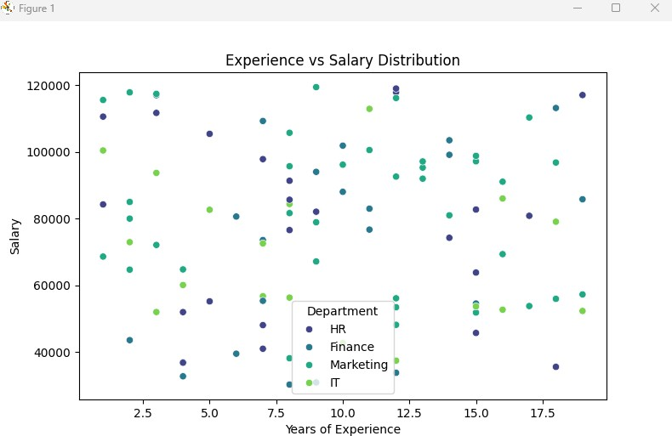plt.title("Employee Distribution by Department") plt.show()

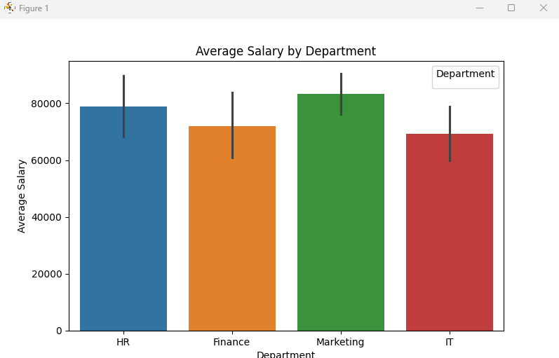

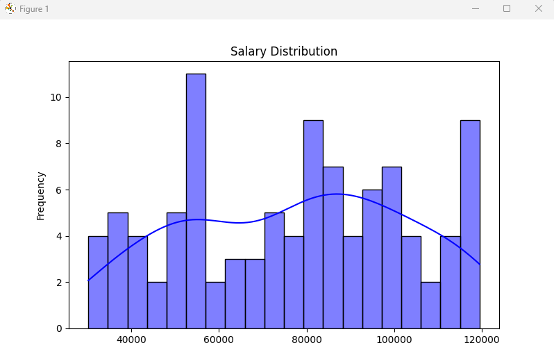

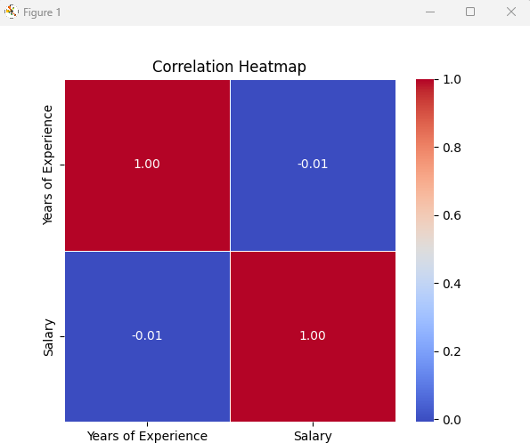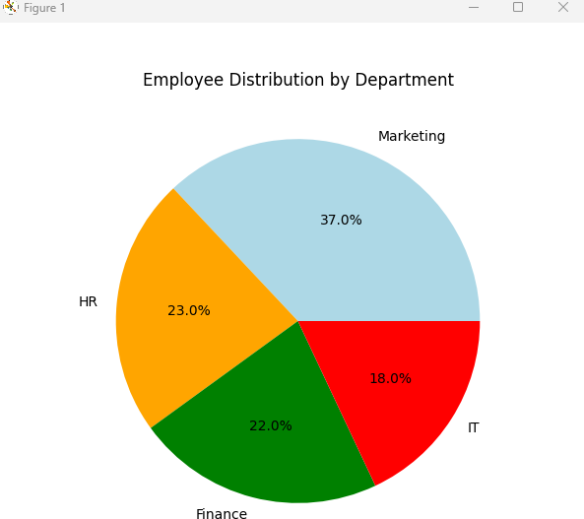

**Conclusion**

**Scatter Plot** – Shows the relationship between **experience and salary** across **departments Bar Plot** – Displays **average salary** by **department**

**Histogram** – Visualizes the **salary distribution Heatmap** – Shows **correlation between features**

**Pie Chart** – Displays **employee distribution by department**